## Installations and Maintenance

To run the application, simply transfer the .exe file from the GitHub Repository to the FIU ICAVE. To edit the project and create a new application, proceed as follows:

1. Use a computer with Windows 7 or Windows 10 operating system
2. Go to the GitHub Repository, download the zip file and save the “Assets” folder somewhere easily accessible

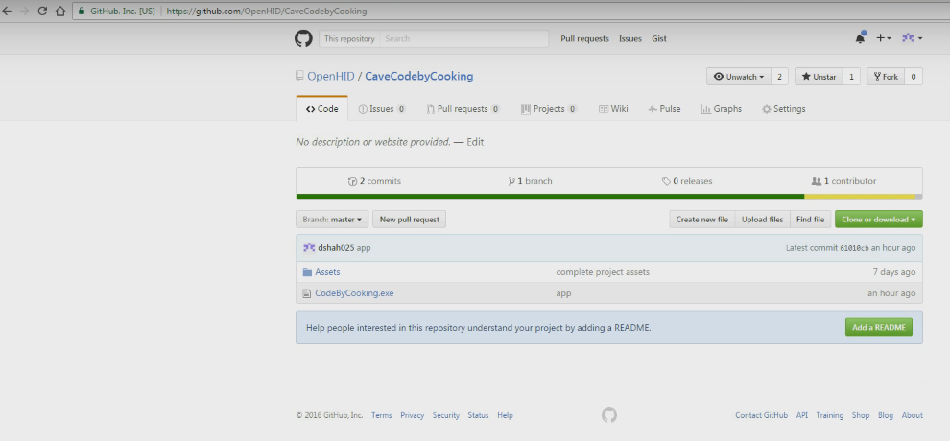

Fig. D.5 – GitHub Repository

1. Download Unity 5.3.2 from the following link <https://unity3d.com/get-unity/download/archive>

Must use version 5.3.2.

1. Download the GetReal3D plugin from the following link <http://icave.fiu.edu/getReal3D_for_Unity_3.3.0_x64.exe>

Note that this is a later version of GetReal3D than the one used for this project. If you have the project files with the assets, then this will not create an issue.

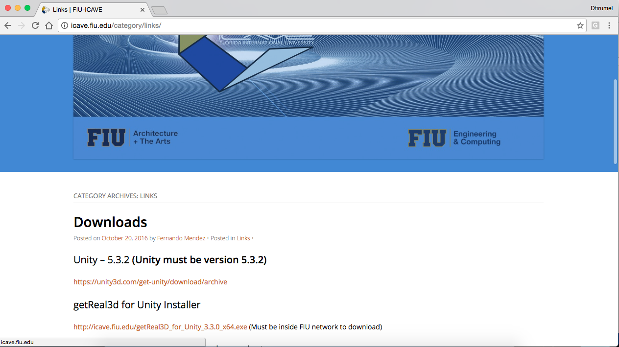

Fig. D.5 – I-CAVE Website with download links

1. Run Unity, create a New Project and then close Unity

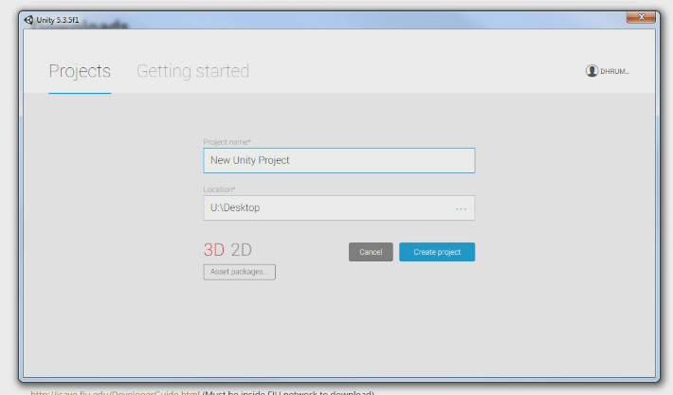

Fig. D.6 – Creating a New Project in Unity

1. Drag and drop the Assets folder you downloaded from GitHub to the New Project Folder

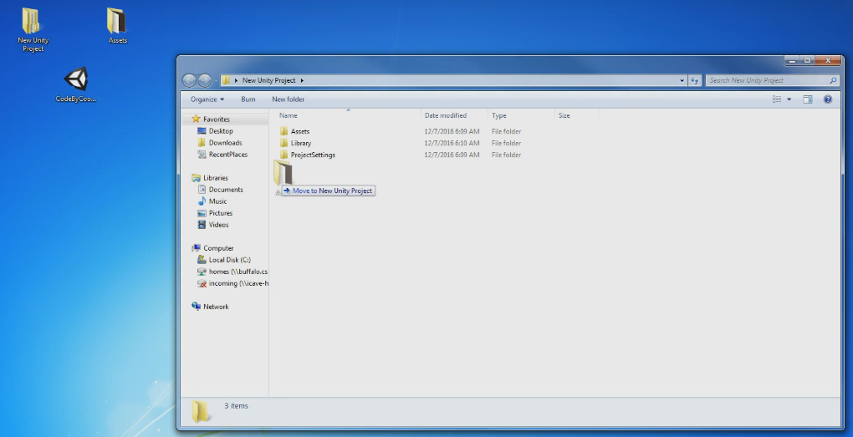

Fig. D.7 – Drag and drop Assets folder

1. Open “Kitchen Test Scene” from the assets if it is not already open
2. Go to File -> Build Settings and build your .exe application file

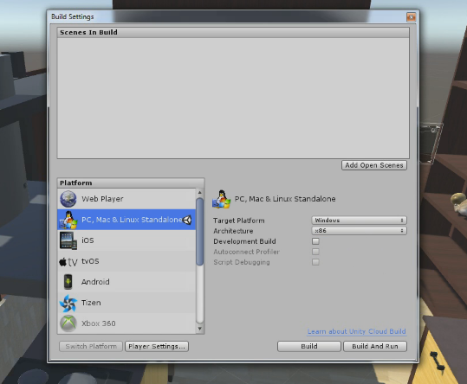

Fig. D.8 – Build the application

1. Save this .exe file and transfer it to the head node of the main I-CAVE machine
2. Ensure that the dtrack, trackd and GetReal3D programs are running on the machine
3. Add the file to the GetReal3D cluster
4. Launch the application
5. Turn on the projectors
6. Wear the 3D goggles with the tracking device, grab the gamepad, enter the I-CAVE and you’re good to go

For maintenance, if you use the project files with the same GetReal3D folder, you should have no issues in running the application. However, the Unity on the main I-CAVE machine needs to support the Unity version with which you build the application. As long as Unity in the I-CAVE machine is the current version, you may use Unity 5.3.2 to build your application. In case there are any upgrades and the application does not run, contact the I-CAVE staff at FIU.